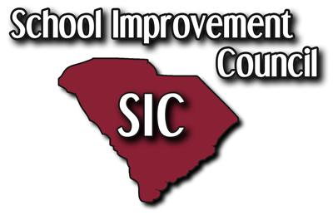

J.P.Thomas Elementary School
October 9, 2018
ANNUAL SIC MEETING
5:00PM
Agenda
- Call to Order Mrs. Cheryl Chandler, SIC Chair
- Welcome & Introductions
- SIC Minutes Review – (May & July 2018) Mrs. Latimore, Principal
- Principal Updates Mrs. Latimore, Principal

- Title One Planning Meeting Mrs. Henryhand-King

- Open Discussion:
- Other:
  - 2018-2019 Projects- JPT Name on School Building
  - Topics for Next Meeting: planning for next school year 2018
  - Upcoming Events:
October 10, 2018- Walk to School Day @8AM
October 12, 2018-Student makeup day/ Half day
October 16, 2018- Healthy & Happy Kids, sponsored by the Junior League of America (Alcorn)
October 31, 2018-Report Cards Issued
November 1, 2018- Report Card Pick up/ Parent Conference Night/Half day for students

Adjournment

John P Thomas Elementary School
School Improvement Council Meeting Dates

October 09, 2018
November 13, 2018
December 11, 2018
January 9, 2019
February 13, 2019
March 13, 2019
April 10, 2019
May 8, 2019
June 12, 2019 TBD (Time)
July 10, 2019 TBD (Time)
*All meetings are scheduled to start at 5:00PM except June and July 2019 meetings
Child care is provided

