Our school counselors are available to provide ongoing social/emotional and physical well-being support to our students, parents, and families.

Things to Do While Stuck Inside Due to Quarantine:

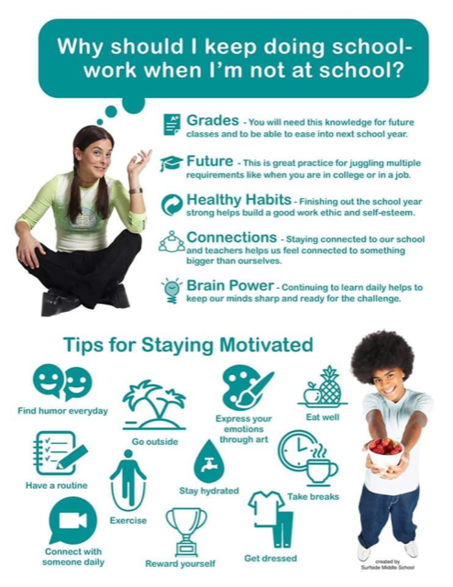

Colleagues

Maslow's hierarchy of needs is a pyramid of needs that all human beings must fulfill to be happy. People can't get to the next highest level of needs met until they first meet lower levels of needs.
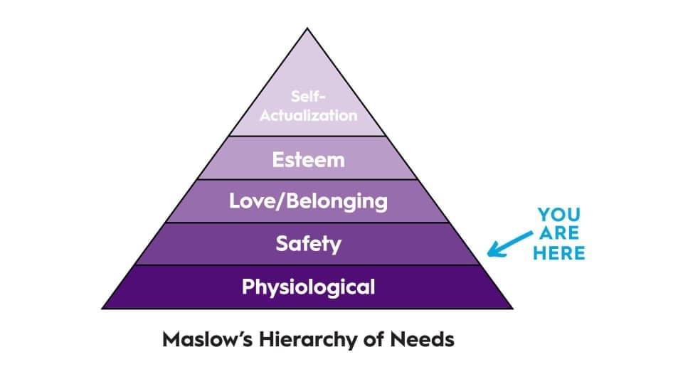
- This is why it’s been hard to focus.
- This is why it feels like it takes you twice as long to get things done.
- This is why you’ve been consumed with ensuring that you have the right “stuff” to sustain your physiological needs.
- This is why you’ve been more irritable.
- This is why you’ve been craving connection.
- This is why you’ve been feeling overwhelmed.
- This is why you’ve been physically exhausted.
- This is why the idea of planning for the future is the furthest thing from your mind right now.
- This is why you only have enough mental energy to focus on the immediate.
- This is why you’ve been instinctively prioritizing self-care and family.
- This is why you’ve been grasping to control what you perceive to be controllable because so much is uncontrollable and unpredictable right now.
- This is normal.
- You are not a slacker.
- You are not “crazy” (Yeah, I know we hate that word).
- You should not compare yourself to others.
- You should not buy into the narrative that you must emerge a “better person”.
- It’s ok to not be as productive - we are experiencing trauma on a global scale.
- It’s ok to “just be” and feel the way you feel about what’s happening around you and/or to you.
- It’s ok to seek help. COVID-19 is a crisis that threatens both our physical and psychological

We are here for you too!!
Conference with your counselor

Contact your counselor :

School Counselors
Angela Cooper Angela.Cooper2@Richlandone.org Grades 8th and 7th M-Z
Contact Number 803-738-7575
Trevisha Mickens Trevisha.Mickens@Richlandone.org Grades 6th and 7th A-L
Contact Number 803-738-7575
Parent Liaison
John Dixon Contact Number 803-908-5673

This is a fun opportunity to check in virtually with each other. Take a moment for yourself. These daily activities are not mandatory and or not meant to take a lot of time. Choose one are trying them all, it’s up to you! Be well and take care of yourself and those you love. You are helping us by staying home!

Day 1: Mindfulness
Mindful Monday
Mindfulness is the ability to be fully present and aware of where we are and what we are doing and not overreacting or feeling overwhelmed by what’s going on around us.
We know certain things can help us keep our sense of calm. Things such as keeping normal eating and sleeping patterns, finding time to exercise. De-stress, find things that decrease your stress. Call a friend, go for a walk, and try something new. Learn a new recipe, take up sewing, do something you’ve put off for a long time. Clean your room! Use the gift of time and space to do somethings that will give you a sense of accomplishment.
For more ideas visit mindful.org at::

https://www.mindful.org/meditation/mindfulness-getting-started/

Think:
Questions to help you stay grounded:
How can I practice self-compassion?
With so much change and uncertainty, knowing so many people are hurting, having to stay away from friends and family we love, the world could use a little kindness.

- To practice a guided loving-kindness meditation: Loving Kindness Meditation Top recommended reading:
- That Discomfort You’re Feeling Is Grief, Harvard Business Review More resources on recognizing and validating grief:
- Grieving the Losses of Corona Virus
- Exercises to aid in practicing self-compassion
- Self-Compassion break, 5 minutes
- Be Kind to Yourself — Right Now, instructions for a lovingkindness practice

While we cannot control the pandemic and all that it brings, we CAN control who we are and what we stand for. We can control how we support and listen to the people around us.
The following strategies can help you maintain your strength and resilience in the coming weeks.
- Stay in the present
- Separate out what you can & cannot control
- Notice & manage your worried thoughts
- Pay attention to joy
- Get active
TAKE IT UP A KNOTCH: Write a thank you note to someone in your
home.

Day 2: Attitude of Gratitude
Gratitude is one of many positive emotions. It’s about focusing on what’s good in our lives and being thankful for the things we have. Gratitude is pausing to notice and appreciate the things we often take for granted, like having a place to live, food, clean water, friends, family, and even computer access. It’s taking a moment to reflect on how fortunate we are when something good happens-- whether it’s a small or big thing.” Making a habit of attitude doesn’t just make us feel good it’s also good for us.

You can build a habit of gratitude by just paying attention each day to things you’re glad to have in your life. Slow down and notice what’s around you. “Wow, the sky is beautiful today! “ “It was so nice of mom to help me yesterday.” “Look at the beautiful star-filled sky.”
Think:
So, let me ask you, what’s good about This moment right now?

Use old magazines and newspapers, cut out and glue pictures of items you are grateful for on a piece of cardstock.
This can include pictures of animals, the world, people, food, homes, and musical instruments—anything you would like.
Display your collages in your home. Encourage your family members to create one also, and share at least one item from their collage with the family.

Take it up a Knotch:

• Emotions are like waves. They come on, peak, and slowly roll out. Practice riding the waves of emotion and learning to tolerate them instead of fighting them or letting them overwhelm (or drown) you.
• Notice and name your feelings, and remind yourself that each feeling is temporary, even if the circumstances remain unchanged. Focus on accepting your feelings and your strength to tolerate them.
• Do not try to plan for the next week or month or indefinite future; take on one moment at a time.
• When all else fails, simply focus on your 5 senses to ground you in the present. Listen carefully for very subtle sounds, look for all the colors in the rainbow, notice how your feet or fingertips feel, attend to a subtle taste in your mouth or scent you can find.

Day 3: Wellness
Dimensions of Wellness
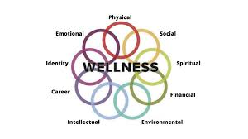
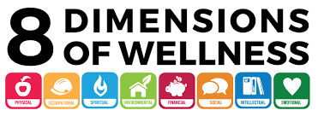

​ Think:
- What is a growth mindset?
- How did Michael Jordan have a growth mindset?
- Why would coaches want someone with a growth mindset?
- What is the difference between a growth mindset and a fixed mindset?
- How did Carson, the 5th grader speaking in the video, use a growth mindset in reading?
- How can you have the mindset of a champion?

One idea about the 8 dimensions of wellness is if you can change your habits, you can change the quality of your life.
Today we will focus on emotional wellness.

Emotional wellness inspires self-care, relaxation, stress reduction and the development of inner strength. It is important to be attentive to both positive and negative feelings and be able to understand how to handle these emotions. Emotional wellness also includes the ability to learn and grow from experiences.

Manage stress
- Stress can damage both emotional and physical wellness. Find an outlet to manage your stress. For some, a workout helps alleviate daily stress. For others, a hobby helps keep them calm. Health Promotion and Wellness has programs available to help manage stress.

Seek balance
- We are pulled in a million different directions daily, making balance hard. Be practical about your responsibilities and what you can feasibly accomplish. Being overwhelmed hinders productivity and focus, and can have physical implications as well. Set realistic goals and priorities, and tackle what needs to be done first. Don’t forget to reserve time for your own needs too!

Be positive
- It is easy to get caught up in negative thoughts or people. Whenever you feel that happening, immediately redirect and focus on the positive parts of a situation. Write positive affirmations down and repeat to yourself as necessary. As much as possible, surround yourself with positive people. It is OK to limit your association with someone because of their negative outlook. If you must interact with him or her, keep exchanges brief and mentally prepare yourself for possible negativity in the conversation.

Accept mistakes
- Mistakes are inevitable. As hard as we may try, no one is perfect. It is important to acknowledge when you have done wrong, accept it, and then move on. The quicker you can address the error, the sooner you are able to move forward. If your mistake involves others, be sure to talk with them as soon as possible. Letting the issue fester can lead to even more stress.

This too shall pass
- Whenever you hit a bump the road remember that this too shall pass. The only constant thing in life is change. While some rough patches go on much longer than we’d like, with time things will look up. Try not to dwell on the bad and look forward to the light at the end of the tunnel.

Accept support
- Often, getting things off your chest makes you feel better. Talk to someone about how you feel. Whether it is a trusted friend or a trained professional, you do not need to go through tough times alone.

Reflection Questions:
- Can I appropriately handle my feelings?
- Can I set and achieve goals that will make me more successful?
- Am I able to keep going in the face of difficulties and setbacks?
- Can I reflect on my thinking and learning?
Day 4: Thoughtful Thursday
The Positive psychology field summarizes happiness with the phrase “other people matter.” The Dalai Lama considered a divine Buddhist monk, has said, “Our prime purpose in life is to help others. And if you can’t help them, at least don’t hurt them.”
In fact, social distancing is an act of human kindness. By staying home, we are putting the health and well-being of others ahead of our own hardships.
Some ideas to think of others:

*send a playlist to a friend you think they would enjoy.
*make get well cards for people in the hospital
*leave a cheerful or inspiring note on three random cars

For more ideas see the Random Acts of Kindness Calendar below

RAK Calendars

Think:
What are some kind acts you can do to make others happy?

Acts of Kindness Challenge
This is a competition can be an effective motivator for increasing kindness. In this challenge, you and family members will recognize when someone does something nice for them unexpectedly and surprise others with random acts of kindness yourself.
Perform three kind acts per week or noticing five kind acts per week. To keep them excited about the challenge, get star stickers to add to a chart or a paper cutout to stick on a bulletin board when they meet their goal.
While you are encouraging each other to be kinder to others, make sure to practice some kindness yourself. Give each family member at least one compliment before the end of the day. Before letting your family go for the day, tell them that you purposely complimented each of them during the day and that you noticed a positive change in his/her mood. Explain that these positive changes are common outcomes of practicing kindness.

Try These Activities:
A little bit of kindness can make the world a brighter place. Here are 75 ways you can show kindness to the people around them:

- Smile at everyone you pass in the hallway, in the store, or walking on the sidewalk
- Hold the door open for people
- Sit by someone who's eating alone
- Put your phone away and give someone your full attention
- Greet people in the hallways
- When you experience something good, share it with people (a book, social media post, YouTube video, article, etc…)
- Don’t gossip
- Talk to someone you don't usually talk to and try to get to know them
- Say please and thank you when you ask for things
- Compliment someone
- Help a classmate when they're confused
- Leave a nice comment on social media
- Ask new people to be in your group during class
- Ask someone how their day's going and genuinely listen to their response.
- Make eye contact when you talk to people
- Forgive someone when they hurt your feelings (even if they don’t ask for forgiveness)
- Give someone positive feedback when they've done something well
- Apologize when you mess up
- Listen when someone needs to talk
- Say thank you a lot
- Share your things
- Tell people to “have a great day”
- Post a positive quote or note on social media
- Sit at the front of the bus and ask your bus driver about their life
- Don’t leave people hanging, follow through when you make a commitment
- Give away things you don’t need any more
- Don’t judge people
- Put a sticky note with a positive message in the hallway above the drinking fountain or bathroom mirror.
- Ask your teacher about their life and what they enjoy doing when they're not teaching.
- Give people the benefit of the doubt
- Randomly text a nice message to your family and friends
- Give someone a hug
- Stop talking and listen
- Be patient
- Let someone go ahead of you in line
- Call and talk to someone you haven't spoken to in a while
- Tell the principal how great your teachers are
- Thank the school cooks for making you yummy food for breakfast and lunch
- Say "I love you" to the people you love
- Clean the dishes after dinner without being asked
- Make sure everyone at the table feels included in the conversation
- High five people you pass in the hallway
- Write a thank you note to someone
- Give someone a thoughtful gift (it doesn't have to be expensive, just thoughtful)
- Leave a nice note on someone’s desk
- Talk to someone at school that you’ve never talked to before
- Bring your bus driver a little treat
- Give someone a tissue when they’re crying
- Find the goodness in people you don’t always get along with
- Be happy for other people
- Surprise your friend with their favorite snack
- Tell someone why they are special to you
- Leave a “have a good day” note in a library book
- Happily participate when you really don't want to
- Be generous
- Write a thoughtful letter or card to someone and mail it to them
- Be honest
- Help a teacher pass out or collect papers
- Offer to clean the whiteboard
- Tell your teacher thank you at the end of class
- Cheer your classmates on
- Give teachers and classmates your full attention when they talk
- Tell the truth
- Make someone laugh with a silly joke (or meme or YouTube video)
- Say thank you when a teacher passes out papers
- Don’t complain
- Do the tasks that no one else wants to do
- Volunteer to tutor or read to elementary students
- FaceTime your grandparents
- Be inviting: invite someone to your house, eat lunch with you, be on your team, play at lunch recess
- When you're arguing or disagreeing with someone, stop and actually listen to their point of view
- Don’t interrupt people
- Tell your bus driver thank you for getting you to school and home safely
- Write a positive message on the sidewalk with colorful chalk
- Be selfless, put other people's interest and needs above your own

Happy Standing
- When you stand in a positive way it can tell your brain you feel happy
- Practice standing in a happy way
- Practice standing in a sad way
- Do you feel different when you stand in these ways?
- Standing in a positive way or ‘power posing’ can help you feel better
- Practice happy standing to help you and others feel better

Day 5: Fun Friday
Let’s have some fun!!!
What’s in a virtual calming room? Online puzzles and games, live animal cameras, coloring, visual relaxation sounds and music, guided meditations, yoga, text lines and hotlines. Try an activity by viewing the calming room below.
Virtual Calming Room

Fun Indoor games
https://www.familyfuntwincities.com/indoor-games-for-kids/

Call your healthcare provider if stress gets in the way of your daily activities for several days in a row.

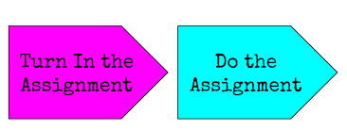

*** Students make sure assignments are turn in on time, please reach out to teachers if assistance is needed, if you need any additional support please contact your counselor.

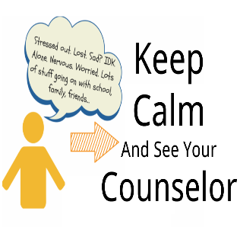

Unleash the Leader Within You!

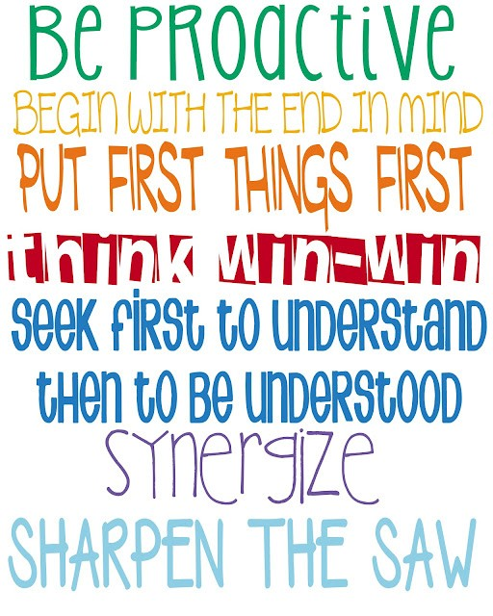

Additional Student Resources

https://portal.sccis.intocareers.org/ (Career Exploration)

https://youtu.be/ikehX9o1JbI (Social Emotional Learning)

https://youtu.be/Z0Og50KyZWc (Social Emotional Learning)

https://youtu.be/NLm2BuW73m4 (Social Emotional Learning)
https://youtu.be/YMM67Le2VHA (Social Emotional Learning)

https://youtu.be/nTII0cyUbQo (Social Emotional Learning)

https://youtu.be/BYXBXPt7FnY (Social Skills)

https://youtu.be/OQ9nnUSu4BM (Social Skills)

https://youtu.be/A1anXJhVamc (Overcoming Anxiety)

https://youtu.be/l7g8Atv27Q8 (Managing Anxiety & Worry)

https://youtu.be/PmBYdfv5RSk (Alleviate Anxiety)

https://youtu.be/FhG-VoRtkKY (A Teen’s Perspective on Stress)

https://bigfuture.collegeboard.org/college-search (College Search)

Parent Resources

Specific Guidelines

Remain calm and reassuring.
- Children will react to and follow your verbal and nonverbal reactions.
- What you say and do about COVID-19, current prevention efforts, and related events can either increase or decrease your children’s anxiety.
- If true, emphasize to your children that they and your family are fine.
- Remind them that you and the adults at their school are there to keep them safe and healthy.
- Let your children talk about their feelings and help reframe their concerns into the appropriate perspective.

Make yourself available.
- Children may need extra attention from you and may want to talk about their concerns, fears, and questions.
- It is important that they know they have someone who will listen to them; make time for them.
- Tell them you love them and give them plenty of affection.

Avoid excessive blaming.

- When tensions are high, sometimes we try to blame someone.
- It is important to avoid stereotyping any one group of people as responsible for the virus.
- Bullying or negative comments made toward others should be stopped and reported to the school.
- Be aware of any comments that other adults are having around your family. You may have to explain what comments mean if they are different than the values that you have at home.

Monitor television viewing and social media.

- Limit television viewing or access to information on the Internet and through social media. Try to avoid watching or listening to information that might be upsetting when your children are present.
- Speak to your child about how many stories about COVID-19 on the Internet may be based on rumors and inaccurate information.
- Talk to your child about factual information of this disease—this can help reduce anxiety.
- Constantly watching updates on the status of COVID-19 can increase anxiety—avoid this.
- Be aware that developmentally inappropriate information (i.e., information designed for adults) can cause anxiety or confusion, particularly in young
- Engage your child in games or other interesting activities instead.

Maintain a normal routine to the extent possible.

- Keep to a regular schedule, as this can be reassuring and promotes physical health.
- Encourage your children to keep up with their schoolwork and extracurricular activities, but don’t push them if they seem overwhelmed.

Be honest and accurate.

- In the absence of factual information, children often imagine situations far worse than reality.
- Don’t ignore their concerns, but rather explain that at the present moment very few people in this country are sick with COVID-19.
- Children can be told this disease is thought to be spread between people who are in close contact with one another—when an infected person coughs or sneezes.
- It is also thought it can be spread when you touch an infected surface or object, which is why it is so important to protect yourself.
- For additional factual information contact your school nurse, ask your doctor, or check the https://www.cdc.gov/coronavirus/2019-ncov/index.html website.

Know the symptoms of COVID-19.

- The CDC believes these symptoms appear in a few days after being exposed to someone with the disease or as long as 14 days after exposure:
- Fever
- Cough
- Shortness for breath
- For some people the symptoms are like having a cold; for others they are quite severe or even life threatening. In either case it is important to check with your child’s healthcare provider (or yours) and follow instructions about staying home or away from public spaces to prevent the spread of the virus.

Review and model basic hygiene and healthy lifestyle practices for protection.

- Encourage your child to practice every day good hygiene—simple steps to prevent spread of illness:
  - Wash hands multiple times a day for at least 20 seconds (singing Twinkle, Twinkle Little Star slowly takes about 20 seconds).
  - Cover their mouths with a tissue when they sneeze or cough and throw away the tissue immediately, or sneeze or cough into the bend of their elbow. Do not share food or drinks.
  - Practice giving fist or elbow bumps instead of handshakes. Fewer germs are spread this way.
- Giving children guidance on what they can do to prevent infection gives them a greater sense of control over disease spread and will help to reduce their anxiety.
- Encourage your child to eat a balanced diet, get enough sleep, and exercise regularly; this will help them develop a strong immune system to fight off illness.

Discuss new rules or practices at school.
- Many schools already enforce illness prevention habits, including frequent hand washing or use of alcohol-based hand cleansers.
- Your school nurse or principal will send information home about any new rules or practices.
- Be sure to discuss this with your child.
- Contact your school nurse with any specific questions.

Communicate with your school.
- Let your school know if your child is sick and keep them home. Your school may ask if your child has a fever or not. This information will help the school to know why your child was kept home. If your child is diagnosed with COVID-19, let the school know so they can communicate with and get guidance from local health authorities.
- Talk to your school nurse, school psychologist, school counselor, or school social worker if your child is having difficulties as a result of anxiety or stress related to COVID-19. They can give guidance and support to your child at school.
- Make sure to follow all instructions from your school.

Take Time to Talk
You know your children best. Let their questions be your guide as to how much information to provide. However, don’t avoid giving them the information that health experts identify as critical to ensuring your children’s health. Be patient; children and youth do not always talk about their concerns readily. Watch for clues that they may want to talk, such as hovering around while you do the dishes or yard work. It is very typical for younger children to ask a few questions, return to playing, then come back to ask more questions.
When sharing information, it is important make sure to provide facts without promoting a high level of stress, remind children that adults are working to address this concern, and give children actions they can take to protect themselves.
Information is rapidly changing about this new virus—to have the most correct information stay informed by accessing https://www.cdc.gov/coronavirus/2019-ncov/index.html.

Keep Explanations Age Appropriate
- Early elementary school children need brief, simple information that should balance COVID-19 facts with appropriate reassurances that their schools and homes are safe and that adults are there to help keep them healthy and to take care of them if they do get sick. Give simple examples of the steps people take every day to stop germs and stay healthy, such as washing hands. Use language such as “adults are working hard to keep you safe.”
- Upper elementary and early middle school children will be more vocal in asking questions about whether they truly are safe and what will happen if COVID-19 comes to their school or community. They may need assistance separating reality from rumor and fantasy. Discuss efforts of school and community leaders to prevent germs from spreading.
- Upper middle school and high school students are able to discuss the issue in a more in-depth (adult-like) fashion and can be referred directly to appropriate sources of COVID-19 facts. Provide honest, accurate, and factual information about the current status of COVID-19. Having such knowledge can help them feel a sense of control.

Suggested Points to Emphasize When Talking to Children
- Adults at home and school are taking care of your health and safety. If you have concerns, please talk to an adult you trust.
- Not everyone will get the coronavirus (COVID-19) disease. School and health officials are being especially careful to make sure as few people as possible get sick.
- It is important that all students treat each other with respect and not jump to conclusions about who may or may not have COVID-19.
- There are things you can do to stay health and avoid spreading the disease:
- Avoid close contact with people who are sick.
- Stay home when you are sick.
- Cover your cough or sneeze into your elbow or a tissue, then throw the tissue in the trash.
- Avoid touching your eyes, nose, and mouth.
- Wash hands often with soap and water (20 seconds).
- If you don’t have soap, use hand sanitizer (60–95% alcohol based).
- Clean and disinfect frequently touched objects and surfaces using a regular household cleaning spray or wipe.

Additional Parent Resources

Talking With Children: Tips for Caregivers, Parents, and Teachers During Infectious Disease

Outbreaks, https://store.samhsa.gov/product/Talking-With-Children-Tips-for-Caregivers-Parents-and-Teachers-During-Infectious-Disease-Outbreaks/SMA14-4886
Coping With Stress During Infectious Disease

Outbreaks, https://store.samhsa.gov/product/Coping-with-Stress-During-Infectious-Disease-Outbreaks/sma14-4885

Centers for Disease Control and Prevention, Coronavirus Disease 2019 (COVID-19), https://www.cdc.gov/coronavirus/2019-ncov/about/transmission.html

Handwashing and Hand Sanitizer Use at Home, at Play, and Out and About, https://www.cdc.gov/handwashing/pdf/hand-sanitizer-factsheet.pdf

School Counselors
Angela Cooper Angela.Cooper2@Richlandone.org Grades 8th and 7th M-Z
Contact Number 803-386-1509
Trevisha Mickens Trevisha.Mickens@Richlandone.org Grades 6th and 7th A-L
Contact Number 803-250-1263
Parent Liaison
John Dixon Contact Number 803-908-5673
**Counselors and Parent Liaison will be available Mondays- Friday 9 a.m. to 11:30.p.m.-1p.m.-2:00p.m.

Because the School Counselors do not provide ongoing therapy, an outside mental health service referral is listed below:

Columbia Area Mental Health Center
Address: 2715 Colonial Drive
Suite 100
Columbia, SC 29203
Phone: (803) 898-4800
Hours of Operation:
8:30am-5:00pm Monday through Friday
* for after-hours emergencies call 833-364-2274.

If you text “Home” 741741 when you are feeling depressed, sad or going through any kind of emotional crisis, a crisis worker will text you back immediately and continue to text with you. Many people prefer text to talking on the phone. It’s a free service to everyone.

